To: Connect 2 Framework
From: The Board of Directors, Evolve Staffing Ltd.
Subject: Confirmation of GDPR and Technical/Organizational Security Measures

As the Director of Evolve Staffing Ltd., I am providing this formal assurance regarding our commitment to data integrity and regulatory compliance.

We recognize that the security of personal data is foundational to our recruitment and staffing operations. Accordingly, I hereby confirm the following:

Accuracy of Information: All details provided regarding our technical and organizational data protection measures are true, accurate, and complete. Our frameworks have been designed to meet the rigorous standards required for handling sensitive professional and personal information.

Current and Future Implementation: We confirm that these GDPR-compliant measures are already in place within our current operational workflows. We further guarantee that all specific technical protocols and organizational safeguards necessary for this engagement will be fully maintained and, where required, further optimized by the date of contract award.

Resource Allocation: Evolve Staffing Ltd. has formally allotted the necessary human and technical resources to manage, monitor, and enforce our GDPR policies. This includes dedicated personnel oversight and robust digital infrastructure to ensure continuous compliance and data sovereignty.

We remain committed to maintaining the highest standards of privacy and security throughout our professional partnership.

Signed,
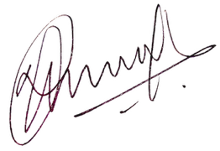

Richard George
Director
Evolve Staffing Ltd.

